EXPERIMENT 12

CURSORS

**Aim:**

* Create a table with attributes students and marks.
* Insert values into the table.
* Create a procedure, and fetch the marks of given id using a cursor.
* Create a procedure, and fetch the highest marks using a cursor.
* Create a table with attributes student id and marks.

C:\Users\sukha\Pictures\OpenBoard\c_1.jpg



* Insert values into the table.

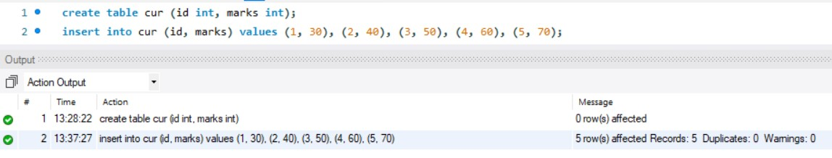

* Create a procedure, and fetch the marks of given id using a cursor.

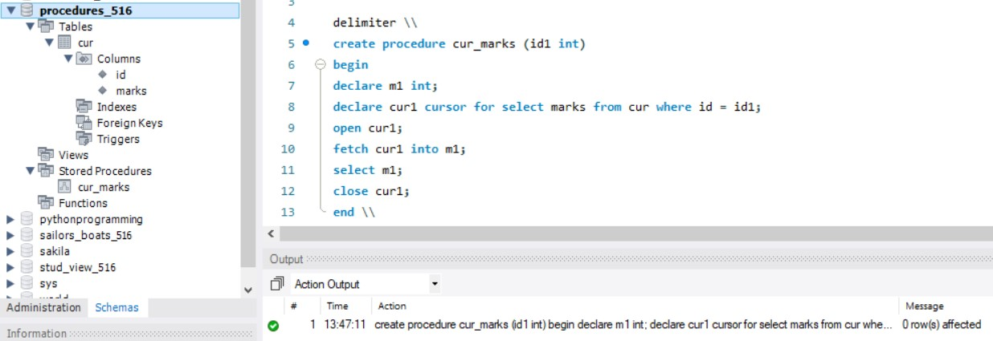

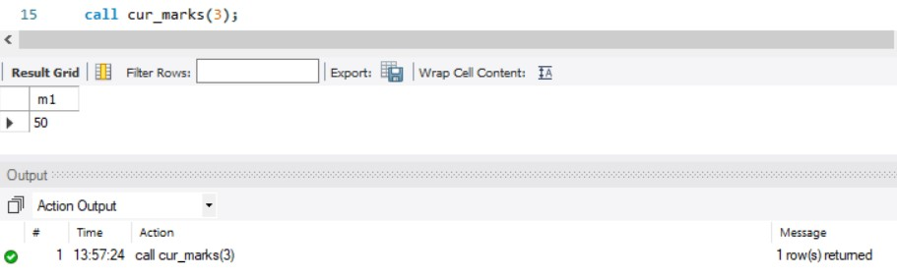

* Create a procedure, and fetch the highest marks using a cursor.

